Backend Development

NodeJs

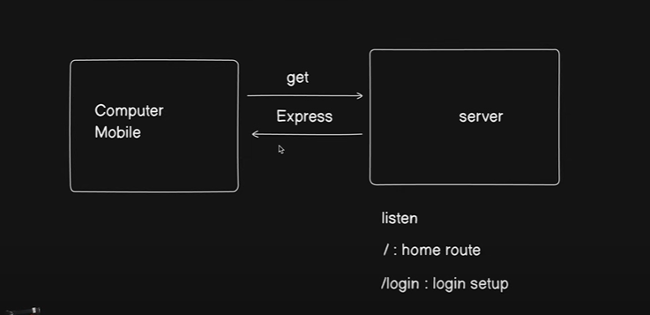

What is node js

Node.js is an open-source, cross-platform runtime environment that allows you to run JavaScript code outside of a web browser. Traditionally, JavaScript was used mainly for client-side scripting in web browsers, but Node.js enables JavaScript to be used for server-side scripting as well, allowing developers to build scalable, real-time, and high-performance web applications.

npm init

The command npm init is used to initialize a new Node.js project. It sets up a package.json file, which is a key component of any Node.js project as it contains metadata about the project, including dependencies, version, scripts, and other information.

**npm init -y**

If you want to skip the interactive setup and use default values, you can use:

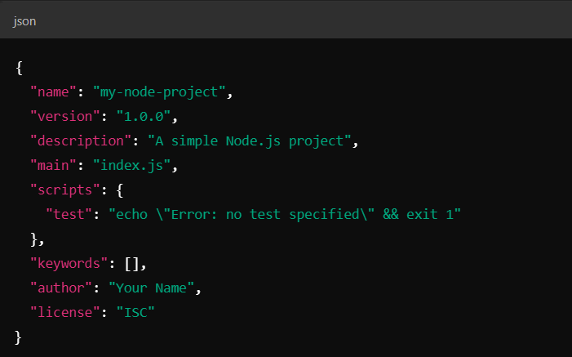

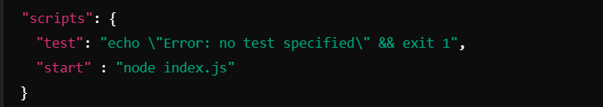

In the "scripts" section of the package.json file, you can define custom commands that you can run using npm. The scripts you included are:

When you run **npm start**, this script will execute the index.js file using Node.js (node index.js).